Khulna
July 4, 2015

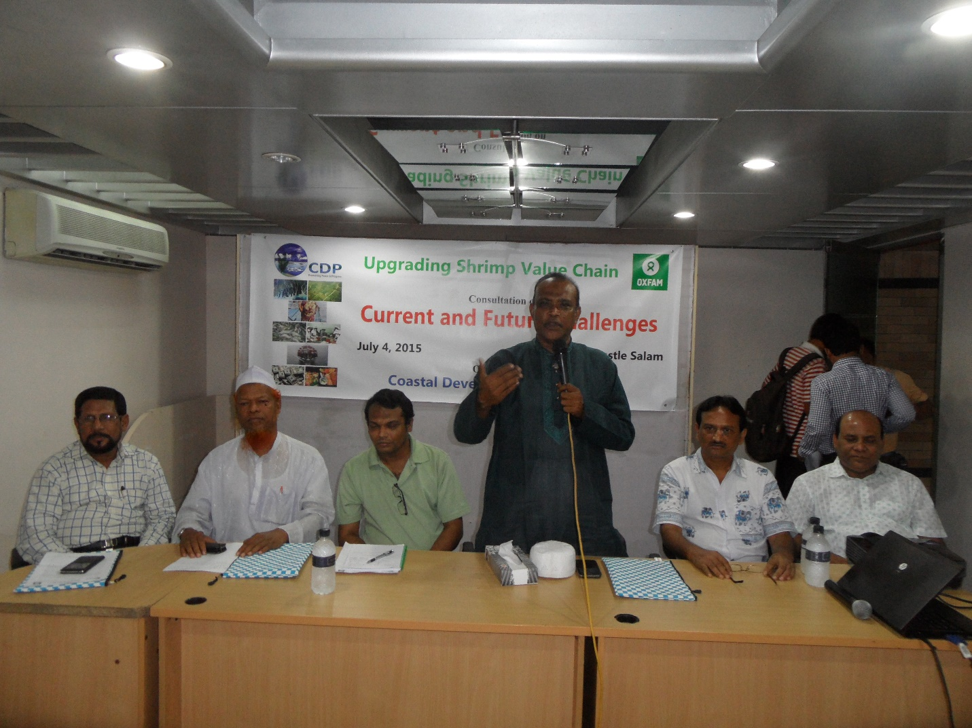
Chief Guest Alhaz Md. Mizanur Rahman Mizan, MP addressing the consultation
Coastal Development Partnership (CDP) and Oxfam Jointly organized a consultation on Current and Future Challenges of upgrading Shrimp Value Chain at Hotel Castle Salam, Khulna. Honorable Member of Parliament of Alhaz Mizanur Rahman Mizan graced the consultation as Chief Guest. Dr. Anwar Hossain Mallick, Director, Department of Environment, Deputy Director of Department of Fisheries Abdul Rashed, Vice President of Bangladesh Frozen Food Exporters Association Sheikh Md. Abdul Baki, Syed Jahangir Hasan Masum, Executive Director, CDP, Khan Alamgir of Oxfam and all relevant stakeholders of Shrimp value chain attended the consultation. CDP Divisional Coordinator S. M. Iqbal Hossain Biplob moderated the consultation.
It is to be noted CDP has been working in upgrading Shrimp value chain since 1996.
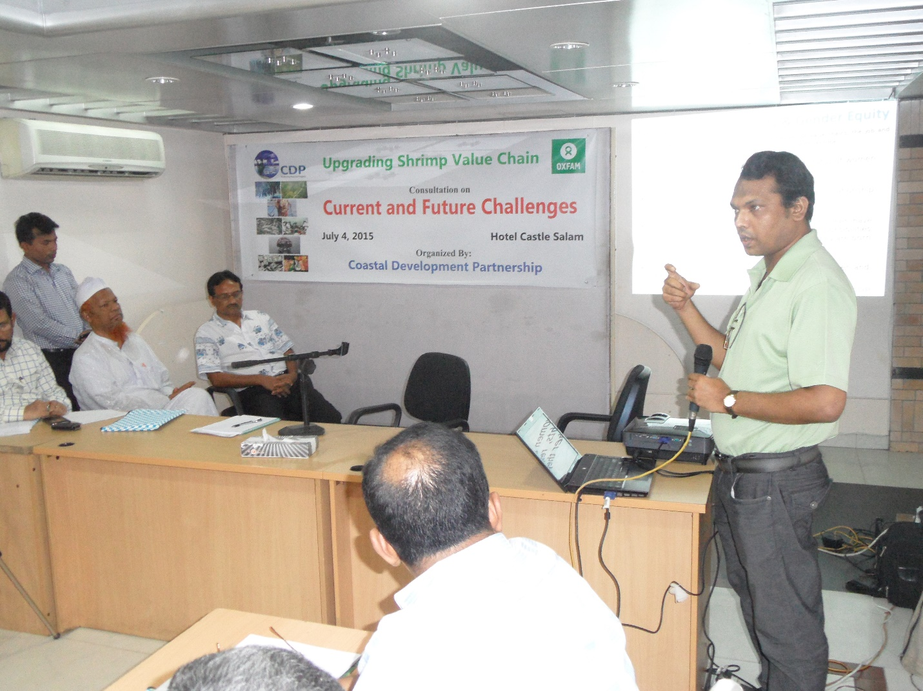
Syed Jahngir Hasan Masum, Executive Director, CDP Presenting overview of Upgrading Shrimp Value Chain

